**Project Design Phase-II**

**Data Flow Diagram & User Stories**

|  |  |
| --- | --- |
| Date | 28 March 2025 |
| Team ID | SWTID1744120590 |
| Project Name | Survey App |
| Maximum Marks | 4 Marks |

**Data Flow Diagrams:**

The Data Flow Diagram for **Survey App** illustrates how data moves through the system, from user interactions to survey app and storage. Below is a simplified representation:

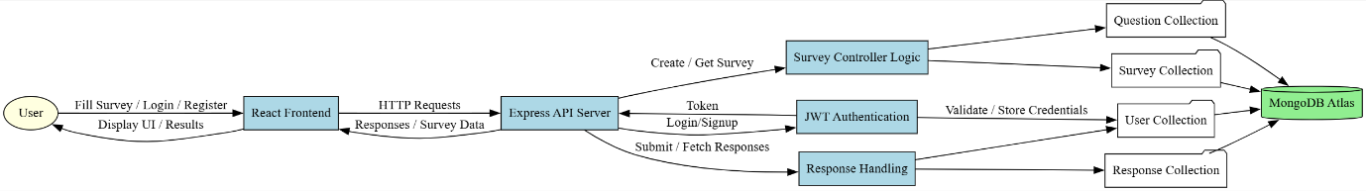

**User Stories**

Use the below template to list all the user stories for the product.

| **User Type** | **Functional Requirement (Epic)** | **User Story Number** | **User Story / Task** | **Acceptance Criteria** | **Priority** | **Release** |
| --- | --- | --- | --- | --- | --- | --- |
| **Respondent** | Survey Participation | USN-1 | As a respondent, I can access surveys via a shared link to submit answers. | Link opens survey form with all questions loaded. | High | Sprint-1 |
| **Respondent** | Survey Participation | USN-2 | As a respondent, I can save partially filled surveys and resume later. | Progress is saved with a unique resume link. | Medium | Sprint-2 |
| **User** | Registration & Auth | USN-3 | As a user, I can register with email/password to create surveys. | Account is created, and dashboard is accessible. | High | Sprint-1 |
| **User** | Registration & Auth | USN-4 | As a user, I can log in via Google for faster access. | OAuth redirect works; profile syncs. | Medium | Sprint-2 |
| **User** | Survey Creation | USN-5 | As a user, I can drag-and-drop questions to customize surveys. | Questions reorder smoothly with auto-save. | High | Sprint-1 |
| **User** | Survey Creation | USN-6 | As a user, I can add multiple question types (MCQ, text, rating). | All question types render correctly in preview. | High | Sprint-1 |
| **User** | Analytics | USN-7 | As a user, I can view real-time response charts for my surveys. | Charts update instantly with new submissions. | High | Sprint-2 |
| **User** | Export Data | USN-8 | As a user, I can export responses to CSV/PDF for analysis. | File downloads with correct formatting. | Medium | Sprint-3 |
| **Premium User** | Subscription | USN-9 | As a premium user, I can brand surveys with my logo/colors. | Custom branding appears on shared surveys. | High | Sprint-3 |
| **Premium User** | Subscription | USN-10 | As a premium user, I can remove "Powered by SurveyAppMERN" footer. | Footer is hidden on published surveys. | Medium | Sprint-3 |
| **Admin** | User Management | USN-11 | As an admin, I can ban users violating terms of service. | User account is deactivated immediately. | Low | Sprint-4 |
| **Admin** | Content Moderation | USN-12 | As an admin, I can review/remove inappropriate survey content. | Surveys are taken down within 1 hour of reporting. | Medium | Sprint-4 |